**SBS PUAN BASELINE**

**REPORT**

**April 2024**

**Table Of Contents**

**INTRODUCTION 4**

**DEMOGRAPHIC ANALYSIS 4**

**SOCIOECONOMIC STATUS ANALYSIS 5**

**INCOME-GENERATING ACTIVITIES ANALYSIS 6**

Motivation for Current Entrepreneurial Activities 7

Proposed Business Ventures 7

Reasons Behind Desire to Start New Businesses 8

Reasons for Not Planning New Businesses 8

**REGRESSION ANALYSIS 9**

Recommendations 9

**Table of Figures**

*Figure* 1 *:Gender of respondents* 4

*Figure* 2 *: Marital status of the respondents* 4

*Figure* 3 *: Scatter plot on daily expenditure on food vs No. of children* 5

*Figure* 4 *: Education-related expenses* 6

*Figure* 5 *: Column chart on net profit from business type* 7

*Figure* 6 *: Correlation between variables* 11

# 

# **INTRODUCTION**

This report presents an analysis of household characteristics and income-generating activities derived from a survey conducted among individuals in SBS Puan cohort. The analysis aims to uncover insights into the socioeconomic landscape and economic aspirations of the surveyed population. The survey explored variables such as marital status, gender, household wealth, education expenses, and participation in income-generating activities of 43 individuals.

# DEMOGRAPHIC ANALYSIS

The demographic analysis of the surveyed population unveils significant patterns across key variables. Gender distribution skews towards females, constituting 88.37% of the sample, with males representing 11.63% as shown in Figure 1. Marital status reveals a predominant prevalence of marriage, with 88.37% of respondents reporting as married, while 11.63% identify as widowed as represented in figure 2. Household size indicates an average of 5 children per household, suggesting substantial family units. Age demographics span from 22 to 59 years, with an average age of 34 years, reflecting a diverse age range within the cohort.

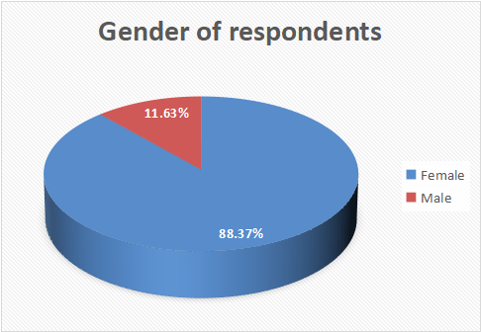

*Figure 1**:Gender of respondents*

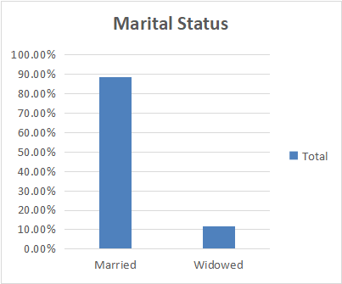

*Figure 2**: Marital status of the respondents*

# SOCIOECONOMIC STATUS ANALYSIS

The analysis of socioeconomic status within the surveyed population reveals significant insights. Household expenditure on food and cooking fuel ranges from Ksh200 to Ksh3500 daily, with an average expenditure of Ksh707.67, reflecting diverse spending patterns. Correlation analysis reveals a weak positive correlation (0.283) between the number of children in the household and daily expenditure on food and cooking fuel, indicating that larger households tend to spend more on food.

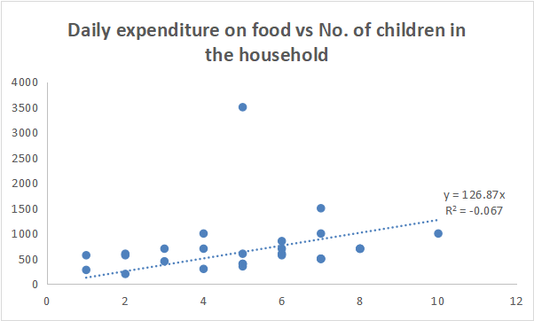

*Figure 3**: Scatter plot on daily expenditure on food vs No. of children*

Regarding basic needs satisfaction, 72.09% of households report having enough income to meet their family's basic needs, while 27.91% indicate otherwise, highlighting varying levels of financial stability.Additionally, a weak positive correlation (0.298) exists between daily food expenditure and education-related expenses, suggesting that households with higher food expenditures also tend to spend more on education.

Furthermore, education-related expenses for the previous school term vary widely, with expenditures ranging from 0 to Ksh200,000 as shown in the histogram below(Figure 3) and an average spending of Ksh80,732.55. There's a weak positive correlation (0.265) between education expenses and average monthly earnings from income-generating activities, indicating that households investing more in education may also have higher earnings.

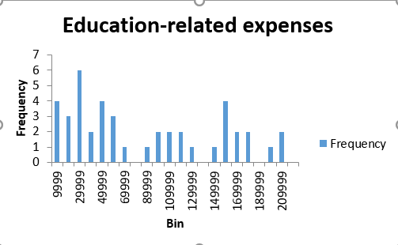

*Figure 4**: Education-related expenses*

# INCOME-GENERATING ACTIVITIES ANALYSIS

Based on the provided data, the analysis of income-generating activities reveals that approximately 65.12% of respondents have engaged in such activities in the past 3 months. The types of businesses reported encompass a diverse array, including bead-work, selling foodstuffs, milk vending, buying and selling livestock, tailoring and selling clothes, operating a salon, providing transportation services (bodaboda), and selling tents. Financially, the average monthly earnings across all respondents stand at Ksh30,714.28, with notable variations among specific activities.

Correlation analysis indicates a moderate negative correlation (-0.285) between total net income from activities and daily expenditure on food and cooking fuel. This suggests that households with higher income from activities tend to spend less on daily food and cooking fuel expenses, potentially indicating a higher level of financial stability.

For instance, buying and selling livestock yield the highest average monthly earnings (Ksh183,333.33), while certain activities such as tents, bodaboda, and selling foodstuffs result in negative net income, indicating challenges in profitability. Despite these variations, the total net profit from all activities amounts to Ksh140,000 , underscoring the economic significance of income-generating ventures within the community.

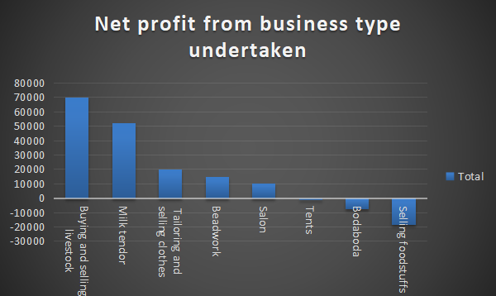

*Figure 5**: Column chart on net profit from business type*

## Motivation for Current Entrepreneurial Activities

The following section outlines the primary motivations expressed by members of the Street Business Cohort for initiating their current entrepreneurial endeavors.

1. ***Income generation*:** Many respondents cited the primary motivation for starting their businesses as the need to generate income. This reflects a common aspiration to achieve financial stability and support their families financially
2. ***Skill Utilization*:** Several respondents mentioned leveraging their existing skills to start businesses, indicating a conscious effort to utilize their expertise for income generation.
3. ***Avoiding idleness*:**Many respondents expressed a desire to avoid idleness and remain productive by engaging in income-generating activities.
4. ***External Triggers*:** Some respondents mentioned external triggers or events that influenced their decision to start businesses, such as receiving financial support from friends or facing unexpected circumstances

## Proposed Business Ventures

**1.*Retail and Trading Ventures*:** Many individuals expressed interest in retail and trading activities such as selling vegetables, Maasai shuka, clothes, beadwork, and operating shops.Some respondents also mentioned plans to sell foodstuffs from home or open small kiosks, indicating a desire to engage in local commerce.

1. ***Agricultural and Farming Endeavors*:** A notable number of respondents considered agricultural ventures, including maize business, farming, and buying and selling livestock.
2. ***Service-Oriented Initiatives*:** Some individuals expressed interest in service-oriented businesses such as tailoring, indicating a demand for customized clothing services within the community. The mention of a hotel suggests a desire to venture into hospitality services, potentially catering to local residents or visitors in the area.
3. ***Miscellaneous Ventures*:**The ambition to establish a petrol station reflects a significant entrepreneurial endeavor, signaling aspirations for large-scale business operations within the community.

## Reasons Behind Desire to Start New Businesses

1. ***Desire for Increased Incom*e:** Several respondents expressed a clear intention to start a business to increase their income and improve their financial situation.
2. ***Family Financial Support*:** Many individuals mentioned starting a business to support their husbands in meeting the family's financial needs.
3. ***Avoidance of Idleness*:** Avoiding idleness emerged as a significant factor motivating individuals to start a business, reflecting a desire for productivity and engagement.
4. ***Self-Reliance and Independence*:** Several respondents expressed a desire to be self-reliant and independent by generating their own income through entrepreneurship.
5. ***Expanding Income Sources*:** The aspiration to expand income sources suggests a strategic approach to financial stability, with individuals seeking to diversify their revenue streams.
6. ***Improving Standards of Living*:** Some respondents articulated their desire to start a business to improve their standards of living and achieve a better quality of life.

## Reasons for Not Planning New Businesses

1. ***Comfortable with Current Business***: Some respondents indicated that they are content with their current business ventures, suggesting satisfaction or success in their existing endeavors.
2. ***Lack of Capital:*** A prevalent reason cited for not starting a business was a lack of capital, highlighting financial constraints as a significant barrier to entrepreneurship.
3. ***Uncertainty in Business Selection:*** Several respondents mentioned that they have not yet identified what type of business to pursue, indicating a lack of clarity or direction in their entrepreneurial aspirations.
4. ***Prior Commitments:*** Some individuals cited existing responsibilities, such as looking after cattle, as impediments to starting a new business, suggesting competing priorities or obligations.

# REGRESSION ANALYSIS

The regression analysis indicates a moderate overall explanatory power of the model (R-squared = 0.6094), with 61% of the variance in household wealth explained by the included variables. The model is statistically significant (p < 0.001), suggesting that at least one independent variable significantly predicts household wealth. Among the predictors, the number of children in the household and income from activities have a significant positive impact on household wealth, with each additional child and unit increase in income associated with an increase in wealth. Conversely, education-related expenses negatively impact household wealth. However, spending on food and cooking fuel does not significantly affect household wealth. Overall, the analysis highlights the importance of considering factors like family size, income sources, and education expenses when examining household wealth.

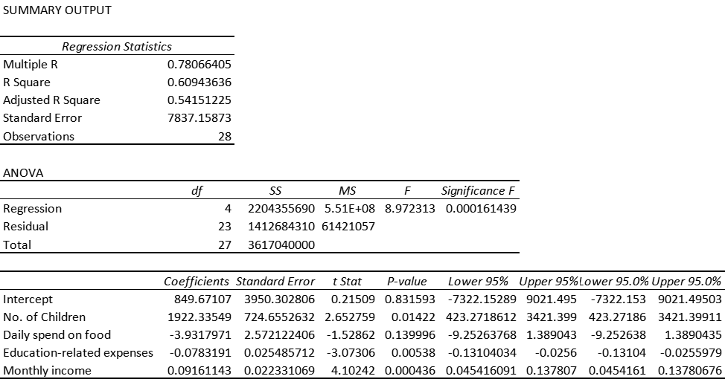

## Recommendations

1. ***Support for Economic Diversification*:** Encourage entrepreneurship and diversification of income-generating activities through training programs, access to microfinance, and market linkages to enhance financial resilience and mitigate risks.
2. ***Investment in Education*:** Provide financial assistance, scholarships, and educational resources to support families in meeting education-related expenses, thereby ensuring equal access to quality education and fostering long-term socio-economic development.
3. ***Strengthen Social Safety Nets*:** Enhance social protection mechanisms and safety nets to support vulnerable households, including widowed individuals and those facing financial hardships, to ensure basic needs satisfaction and prevent economic vulnerabilities.
4. ***Promotion of Gender Equality*:** Implement gender-sensitive policies and initiatives to address gender disparities in economic participation and access to resources, empowering women economically and promoting inclusive development.
5. ***Community Development Initiatives*:** Facilitate community-driven development initiatives, including infrastructure development, healthcare services, and vocational training programs, to enhance the overall well-being and resilience of the surveyed population.

In summary, the analysis sheds light on the socioeconomic dynamics and economic activities within the SBS Puan cohort. Despite facing challenges, the community demonstrates resilience and potential for growth. To capitalize on these strengths and address existing disparities, targeted interventions focusing on entrepreneurship, education, and social support are crucial. By working together, stakeholders can foster a more equitable and prosperous future for all members of the community.

**Appendices:**

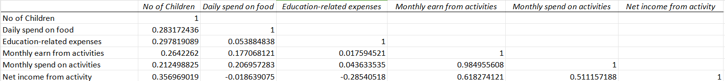

*Figure 6**: Correlation between variables*